SOLAR D-LITE
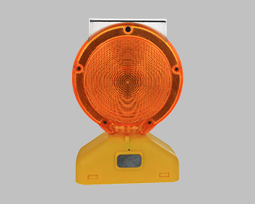

Interplex Solar’s newest addition to our Warning Light platform promises to transform the lighting industry as its disruptive pricing, we feel, eliminates the need to ever purchase battery lights again. Interplex Solar has been delivery high quality, leading edge solutions for decades. Using our many years of experience and global presence, we are now delivering the Solar D-Lite to our Customers at price points that will help eliminate conventional battery devices
- Modes of Operation: Flashing and Steady Burn
- Material: ABS base, Polycarbonate Lens
- Power Supply: NiMH battery Pack
- High Intensity LED’s provide intense light output
- Optical Lens provides radiant light disbursement
- Available Colors: Amber & red
- Viewing Distance > ½ Mile
- Quality Assured: 2 year Limited Warranty

www.Interplexsolar.com

